Amazon EC2 instance -Lifecycle

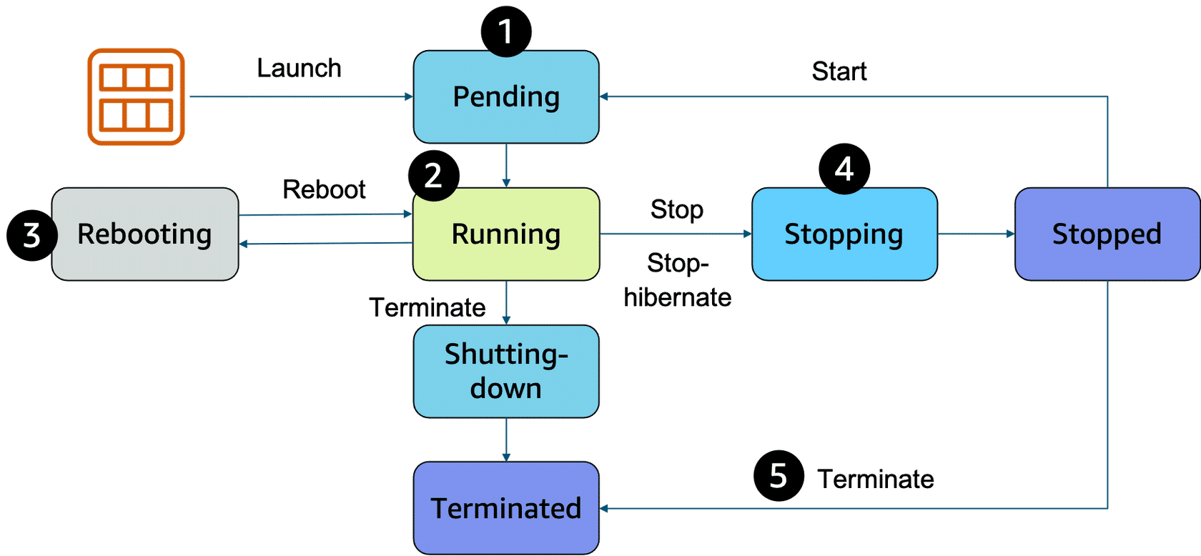

Pending: -
- When you launch an EC2 instance, it enters the pending state.
- Billing did not start.
- At this stage, the instance is preparing to enter the running state.
Running: -
- it's ready to use.
- billing begins.
- an instance is running, you can take other actions on the instance, such as reboot, terminate, stop, and stop-hibernate.
Rebooting: -
- Rebooting an instance is equivalent to rebooting an operating system.
- The instance keeps its public DNS name (IPv4) and private and public IPv4 addresses.
Stopping: -
- It enters the stopping and then stopped state. This is similar to when you shut down your laptop.
- When you stop and start an instance, your instance can be placed on a new underlying physical server.
- Your instance retains its private IPv4 addresses and if your instance has an IPv6 address, it retains its IPv6 address.
- When you put the instance into stop-hibernate, the instance enters the stopped state, but saves the last information or content into memory, so that the start process is faster.
Termination: -
- When you terminate an instance, the instance stores are erased, and you lose both the public IP address and private IP address of the machine.
- Termination of an instance means that you can no longer access the machine.
- As soon as the status of an instance changes to shutting down or terminated, you stop incurring charges for that instance.
Difference between stop and stop-hibernate
When you stop an instance, it enters the stopping state until it reaches the stopped state. AWS does not charge usage or data transfer fees for your instance after you stop it. But storage for any Amazon EBS volumes is still charged. While your instance is in the stopped state, you can modify some attributes, like the instance type. When you stop your instance, the data from the instance memory (RAM) is lost.
When you stop-hibernate an instance, Amazon EC2 signals the operating system to perform hibernation (suspend-to-disk), which saves the contents from the instance memory (RAM) to the EBS root volume. You can hibernate an instance only if hibernation is turned on and the instance meets the hibernation prerequisites.

Resources
(opens in a new tab)
(opens in a new tab)
(opens in a new tab)
For more information, see the following resources:
- AWS user guide: Amazon EC2: Instance Lifecycle(opens in a new tab)
- AWS user guide: Hibernation Prerequisites(opens in a new tab)
- AWS website: Amazon EC2 Pricing(opens in a new tab)
- AWS website: Amazon EC2 On-Demand Pricing(opens in a new tab)
- AWS website: Amazon EC2 Spot Instances Pricing(opens in a new tab)
- AWS website: Amazon EC2 Reserved Instances Pricing

